

**Clubs and Societies 2019-20**

**Clubs and Societies at WBCA**

At West Bromwich Collegiate Academy, we believe students can be a success if they are given the right opportunities. This is why every member of staff in the Academy has committed to offer at least one club either after school or during lunchtime.

Below you can see the clubs that we offer and in this booklet there is a sign up sheet which should be passed back to your form tutor. Clubs will start from Monday 23rd September unless otherwise indcated. Some clubs which involve outside agencies will have later start times.

This is our first offering, and it will change in time, some clubs may run all year but some may run for a shorter time. Clubs may not run if there is not sufficient interest from the students.

Homework club does not require a sign up but is a drop in for students when they wish.

Please note that some clubs have entry requirements and trials. All clubs are dependent on student’s good behaviour and if this is not the case they will be removed from the club.

Where clubs are oversubscribed, we will rotate access to the club. If this is the case, students may attend for a term and then if there is a waiting list be asked to allow other students access to the club. Where a club has a waiting list, if students are not regularly attending they may lose their place.

Students attending clubs will be released through main reception only.

**Timetable**

**After School – 3:10-4:10 unless specified.**

|  |  |  |  |
| --- | --- | --- | --- |
| **Monday** | **Run for All** | **Girls Football** |  |
| **Tuesday** | **Homework** |  |  |
| **Wednesday** | **Homework** | **Theatre School** | **Language Club** |
| **Thursday** | **Boys Football** | **Science Club** |  |
| **Friday** | **Homework** | **Escape Room** |  |

**Lunch Time**

|  |  |  |  |
| --- | --- | --- | --- |
| **Monday** |  |  |  |
| **Tuesday** | **Pop Choir** | **Rock Band** |  |
| **Wednesday** | **Confidence Building** | **Lego Club** |  |
| **Thursday** | **Harry Potter** |  |  |
| **Friday** |  |  |  |



**Sports and Fitness**

**Sports Clubs and Academy Teams**

Sports clubs will change each term and bring in a range of different sports:

**Boys and Girls Football Teams**

**Capacity: Open to all for trial, max number: 18 per team**

**Time: Vary with fixtures and practice.**

**Girls Football Mondays 3:10pm – 4:10pm**

**Boys Football Thursdays 3:10pm – 4:10pm**

Would you like to represent the academy in football?

Training sessions, league games, friendly games and potentially coaching from WBA FC development coaches is on offer!

Please note due to weather conditions, this club maybe cancelled and you will be notified. 18 players will be selected for this club.

**Run 4 All**

**Capacity: 15**

**Time: Monday 3:10pm – 4:10pm**

Run 4 All is a friendly run together group offering weekly sessions at WBCA.

Our mission is to get outside, get fit and enjoy ourselves!

Exercise is great for physical and mental health, but it can be hard to stick to. Training with others makes it more enjoyable and easier to keep going.

Please don't worry if you don’t exercise now – Run 4 All is here to help!

* Warm up and stretch exercises
* Progressive running programme
* Breathing techniques
* Socialising with friends

**Wellbeing Club**

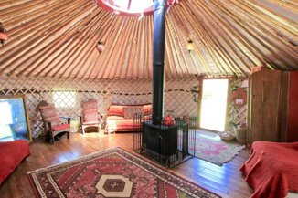**Capacity: 30**

**Time: xxxxx 3:10 – 4:10**

A club that is for everyone! Harness your power, mind, body and spirit through controlled exercise. Increase your strength, flexibility and endurance whilst allowing your mind and spirit to feel calm and relaxed.​

​

All abilities welcome – you go at your own pace and what you feel comfortable with.​

​

Weekly sessions that change each term so you can experience a wide range of activities that will help build confidence and strength that you can then practice at home.

Just some of the activities we can offer to help with fitness and wellbeing…​

* Tai Chi​
* Pilates​
* Meditation​
* Yoga​
* ****Body Balance​
* Strength Training​
* Relaxation Training

**What Else Should You Know?**

Membership available for each activity that will run between 3 – 4 weeks.​

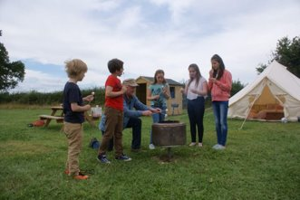Possibility of external classes (like yoga class, martial arts or get people in, sign up required for these) ​

Finally ending with a wellbeing retreat in the summer term, where you can practice all these techniques in a wide open outdoor space with glamping, nature activities, star gazing and marshmallows by the campfire.



**Art, Drama and Music**

**Hippodrome Theatre School**

**Capacity: 30**

**Time: Wednesdays 3:10pm-4:10pm**

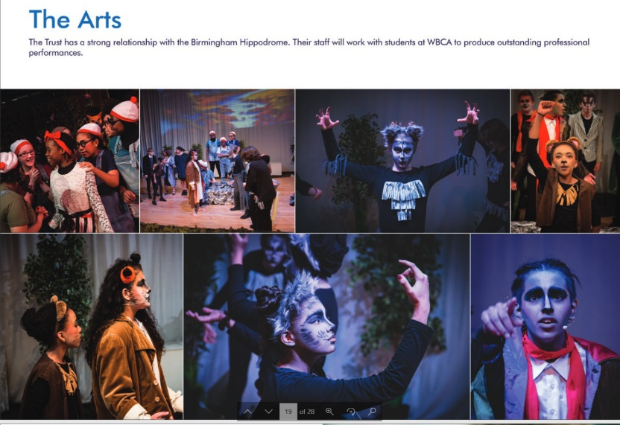The Academy has partnered with the Birmingham Hippodrome to run a theatre school at the Academy every week. With professional support from the Hippodrome we will look to:

* Create and perform shows and performances to a professional standard.
* Have opportunities to visit and potentially perform at the Birmingham Hippodrome.
* Undertake the Bronze Arts Award
* Take part in workshops themed around current Hippodrome Shows.

There will be involvement for talents in drama, dance, music, set design, costume and much more in both our Theatre School and Drama Club. Auditions will be held for performances.

**Drama Club**

**Capacity: 30**

**Time: Tuesday Lunchtime**

If you have an interest in Drama or just want to have fun whilst learning valuable skills, this club is for you!

Within Drama club there will be opportunities to take part in fun imaginative games and exercises, create original pieces of Drama and perform to others in school.

**So, let’s have fun!**

In this club you will build on your confidence, creativity and the ability to work with others. Drama club will also occasionally link up with Theatre club and provide opportunities to for students to take part in auditions for shows and develop a new skill set.

**Art Club**

**Capacity: 30**

**Time: Wednesday 3:10pm – 4:10pm**

Come to Art Club and EXPRESS YOURSELF!​

Lots of art, craft and design activities for you to come along and try out or even become an Art master and teach others your special skill!

Art club will fit in with events happening in and around the school such as making items for the Christmas fair but there are plenty of opportunities for other arty projects!​

Draw, colour, paint​

* Knitting, pom poms, crochet, craft​
* Seasonal Art and Crafts – pumpkin colour/ carve, Christmas fair​
* Paint Pour​
* Character drawing​
* Tie Dye



**Rock Band**

**Capacity: 12**

**Time: Tuesday Lunch**

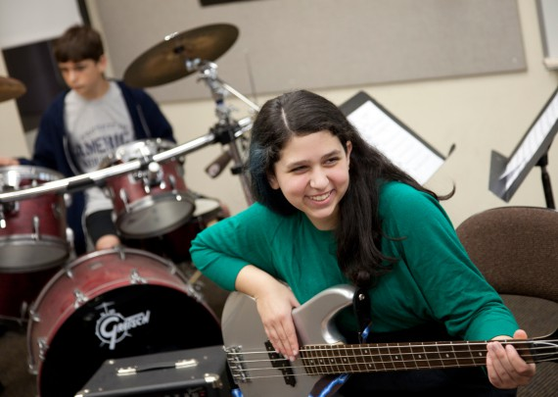Ever wanted to master a classic guitar riff? Wow the crowd with an epic drum solo? Or even sing your heart out to a big, big track? Then come and join in WBCA's new rock band club! Whether you have never picked up an instrument before, or you can already play a few tunes, all are welcome. All you need to bring is a desire to learn. For more information, see Mr Shakespeare.

**Pop Choir**

**Capacity: 30**

**Time: Tuesday Lunch**

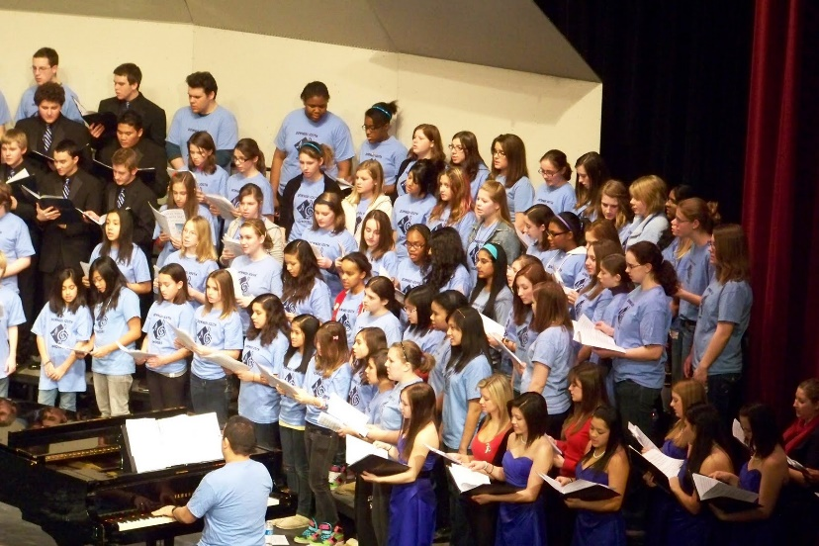Do you like to sing? Would you like to be part of a great singing group? If so, come along to Pop Choir on a Tuesday lunchtime in the Music Studio. We’ll be singing a range of both pop and musical theatre songs, whilst having lots of fun at the same time! Pop Choir is open to anyone who enjoys singing or wants to gain more confidence!



**Games and Social Clubs**

**Games Club**

**Capacity: 30**

**Time: Thursday 3:10pm – 4:10pm**

This club welcomes all pupils! Each week, Games Club provides the opportunity to learn and play the most popular board games, card games, dice games and competitive and collaborative games. Games are great for learning new skills and making friends!

We are keen to discover new games, so we encourage members to bring their own games from home and teach us them – there is always an opportunity to learn a new favourite game!

It is great to spend time with people playing games and we have a lot of fun!

**Lunchtime Club**

**Capacity: Invitation Only**

**From 12:35pm – 1:00pm Mrs Martin**

After you have eaten your lunch in the dining hall, show your pass to come to Inclusion. We will have some games to play, some books to read, or just a bit of time to chat to people to get some support.

**Confidence Building**

**Capacity: 20**

**Time: Wednesday Lunch**

Worried about starting a new school? Want to build your confidence and make friends?

Our Hippodrome worker Ben will be running a number of fun icebreaking games on Wednesday Lunchtime throughout the first term.

Come along and take part in supervised activities where we will work to make sure you feel happy and over time work build your self-confidence.

**Carrom Club**

**Capacity: 16**

**Time: Monday 3:10pm-4:10pm**



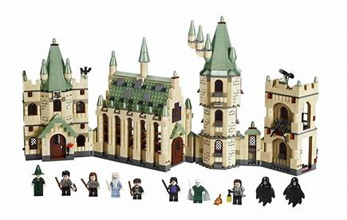

**Lego Club**

**Capacity: 26**

**Time: Tuesday Lunch Time**

Love Lego –then join Lego club!

What’s the best thing you’ve ever built?

What can you design and make yourself?

Do you like to follow instructions or do you prefer to make your own design?

Can you build a life-sized house out of Lego?

****Have you been to Legoland?

Let’s find out the answers to all of these things at Lego Club!



**Harry Potter Appreciation Society**

**Capacity: 30**

**Time: Monday Lunch**

Are you a fan of Harry Potter?

Do you dream of being a student at Hogwarts?

Would you like to spend time with other people who like Harry Potter as much as you do?

Then join the Harry Potter Appreciation Society!

* Watch the films
* Read the books
* Discuss all things Potter!
* Crafting / drawing / making activities
* Make some Butterbeer
* Visit the Warner Brother’s Studios in London

And more!!!



**The Brain Trust**

**Capacity: 30**

**Time: Friday 3:10 - 4:10**

**The Brain Trust Needs You!**​

​

Do you like solving puzzles?​

* Did you enjoy some of the puzzles you did on the Induction Day?​
* Do you like to exercise your mental agility?​

All are welcome​

There are puzzles and quizzes to suit all interests and abilities.

**Academy Escape Room**

**Capacity: Team of 6**

**Time: Friday 3:10-4:10**

West Bromwich Collegiate Academy proudly presents…​

​

**CONFISCATED - A brand new ESCAPE ROOM**​

**Coming soon….**



**The Story:**​

Your friend brought their most prized possession into school and played with it in class instead of doing their work. The teacher was not happy and confiscated the possession, locking it away in the classroom. ​

You have decided to help your friend and have one hour to sneak into the room, find the item and escape before the teacher returns. The trouble is, your friend won’t tell you what the item is and you have no idea where to find it. Hopefully there will be some clues to assist you on your rescue mission!

**FAQ**​

**What is an Escape Room?**​

Teams of 6 students will be invited into a room where you will have one hour to solve a series of puzzles and escape.​

​

**When?**​

Friday after school​

​

**How do I take part?**​

Gather your team of 6 and sign up on the Student Portal when asked​

​

**Will I be locked in the room?**​

No, you will be able to leave the room at any time



**Journalism, Film and Debating**

**Debate Mate**

**Capacity: 20 (Priority to Pupil Premium Students)**

**Time: TBC After School (Note this club does not start until 11th November) Day to be decided in discussion with Birmingham University.**

Debate Mate is a national programme dedicated to teaching young people how to debate in a formal style.

It is supported by students from the University of Birmingham who will come to the Academy to coach and mentor you.

* Learn how to present like a pro
* Learn how to make arguments and respond to others
* Get skills that will help you throughout your life
* Explore key issues and learn to argue both sides
* Become a confident speaker
* Become a leader

The programme builds to regional and national championships as well as participation against other schools in the Urban Debating League.

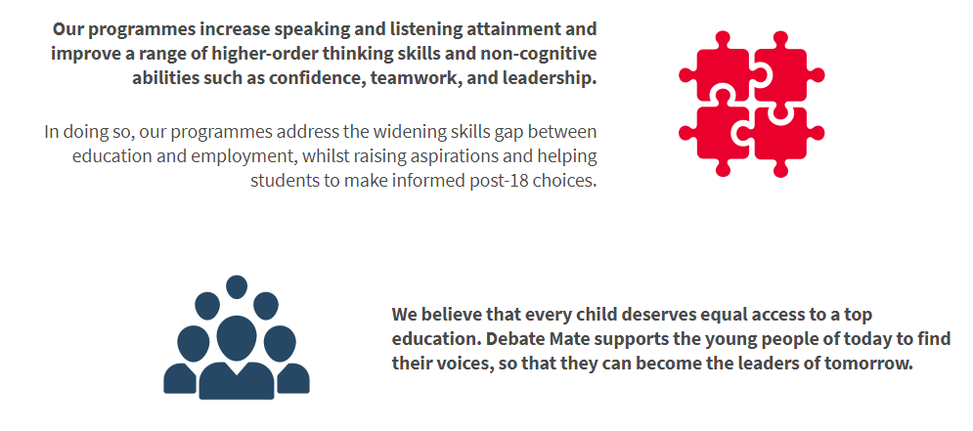

**Journalism Club**

**Capacity: 30**

**Time: Thursday 3:10pm-4:10pm**

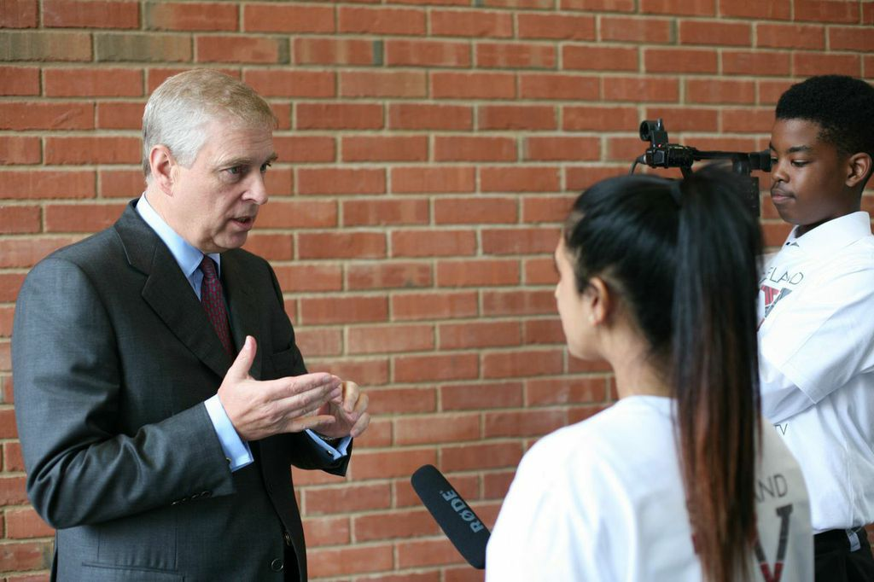Reporting the latest news from WBCA and our community​.

​

You could interview Mr. Faux, write a report on a recent football match or even let us know what's for lunch next week in the canteen!

The stories are down to you.​ ​ Possibility to visit the BBC Birmingham studios on a trip.

**Film Studies Club**

**Capacity: 30**

**Time: Monday 3:10pm-4:10pm**

Film studies will involve watching and analysing films.

You will look at film language elements such as sound, lighting, editing, performance and cinematography. This will link in nicely to one of your L4L themes 'Silent Movies. You will have the opportunity to take part in practical filmmaking exercises including, script writing, film storyboarding and potentially short film making.



**Subject Based Clubs**

**Homework Club**

**Capacity: No Limit**

**Times:**

**Tuesday 3:15-4:15 Miss Phelan**

**Wednesday 3:15-4:15 Mrs Martin**

**Friday 3:15-4:00 Mrs Martin**

For students who may struggle to complete their homework at home, for those who require a bit of support; or those who would just rather complete their homework in a quiet environment. Come along to Inclusion and get some help with your homework.

Laptops will be available for students who need to access the internet or complete their homework online.

**WBCA Time Team**

**Capacity: 30**

**Time: Wednesday 3:10pm-4:10pm**

Join WBCA Time Team and find out about all things History…

* Key events that shaped the world
* Important people from the past
* How and why have things changed over time?
* Historical mysteries that have not been solved…
* How do historians find out about the past?
* Learn about and develop your own historical skills.
* Play historical games. 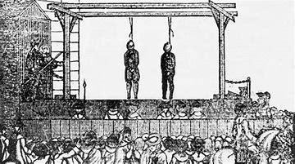
* Find out more about local history.
* Watch Horrible Histories!



**Science Club**

**Capacity: 26**

**Time: Thursday 3:10-4:10**

* Do you have an enquiring mind and a curiosity to learn about the world around you?​
* Do you crave the answers to the big questions such as ‘Why does life on Earth exist?’​
* Do you have a yearning to make a difference to to the community and maybe even the world, like Greta Thurnberg?​

Or do you just want to have some fun, try out some new experiments and learn a bit more about Science?

**Languages Club**

**Capacity: 20 (Priority to Pupil Premium Students)**

**Time: Wednesday after school 3:30-4:30**



¿Hablas español?, parlez vous Francais? Parli Italiano?

Do you want to the master the fundamentals in French, smash the basics in Spanish and get involved in Italian? Languages club is the perfect place to have fun with your friends and pick up another language (or three!) using the newest technology and apps. Discover different countries, cultures and cuisines and take part in language games every week!

**Sign Up Sheet**

After reading the booklet please place a tick next to clubs you would like to attend.

I would like to sign up for the following clubs:

**After School – 3:10-4:10 unless specified.**

|  |  |  |  |  |  |  |
| --- | --- | --- | --- | --- | --- | --- |
| **Monday** | **Run for All** |  | **Girls Football** |  |  |  |
| **Tuesday** | **Homework** |  |  |  |  |  |
| **Wednesday** | **Homework** |  | **Theatre School** |  | **Language Club** |  |
| **Thursday** | **Boys Football** |  | **Science Club** |  |  |  |
| **Friday** | **Homework** |  | **Escape Room** |  |  |  |

**Lunch Time**

|  |  |  |  |
| --- | --- | --- | --- |
| **Monday** |  |  |  |
| **Tuesday** | **Pop Choir** | **Rock Band** |  |
| **Wednesday** | **Confidence Building** | **Lego Club** |  |
| **Thursday** | **Harry Potter** |  |  |
| **Friday** |  |  |  |

I understand my child has applied for the above clubs and give permission for them to attend. I understand it is my responsibility to either collect my child or that they have an independent means to travel home at the end of the clubs.

Student Name _____________________________________________

Student Form _____________________________________________

Parents Signature _____________________________________________