Accessibility Plan

Approved by: | Mrs Kiran Egan, Chair of SPC | Date:
Last reviewed on: | February 2022
Next review due by: | September 2022

Table of Contents
1. Aims 2
The Academy 2
The Trust 2
For the Students 3
For the Staff and Leaders 3
Academy Principles 4
For Students 4
2. Legislation and guidance 5
3. Action plan 6
4. Monitoring arrangements 10
5. Links with other policies 10
Appendix 1: Accessibility audit 11

1. Aims
Schools are required under the Equality Act 2010 to have an accessibility plan.
The purpose of the plan is to:
- Increase the extent to which disabled students can participate in the curriculum
- Improve the physical environment of the school to enable disabled students to take better advantage of education, benefits, facilities and services provided
- Improve the availability of accessible information to disabled students
- To ensure access to the curriculum for all students
Our school aims to treat all its stakeholders fairly and with respect, taking reasonable steps to avoid putting anyone at a substantial disadvantage. This involves providing access and opportunities for all students without discrimination of any kind.

The Academy

At WBCA we are committed to an inclusive education for local students at every ability level, a rigorous grounding in academic fundamentals and equipping students for the future through teaching them relevant and cutting-edge skills for the era in which they live.

Most importantly we believe that every student should be safe, happy, ambitious for themselves and respectful of all. We aspire to create students who are strong academically but also decent upstanding people that the community can be proud of.

The Trust

West Bromwich Collegiate Academy is part of the Shireland Collegiate Academy Trust.

The Collegiate Academy Trust was founded by Shireland Collegiate Academy, a three times Outstanding Academy in Sandwell in the West Midlands.

In 2016 the Academy Trust was reactivated and was granted Multi Academy Trust status by the Department for Education. This was done following a period of intense capacity building in order for the Trust to be prepared to manage multiple institutions. Since that point the Trust has successfully bid in two previous free school waves.
The Trust has a full vision statement based on the following values: Leading Learning, Promoting Cohesion, Changing Attitudes as an institution; and Aim Higher, See Further and Be Concerned for Everyone for students. These common values can be seen across all the Academies in the Trust.

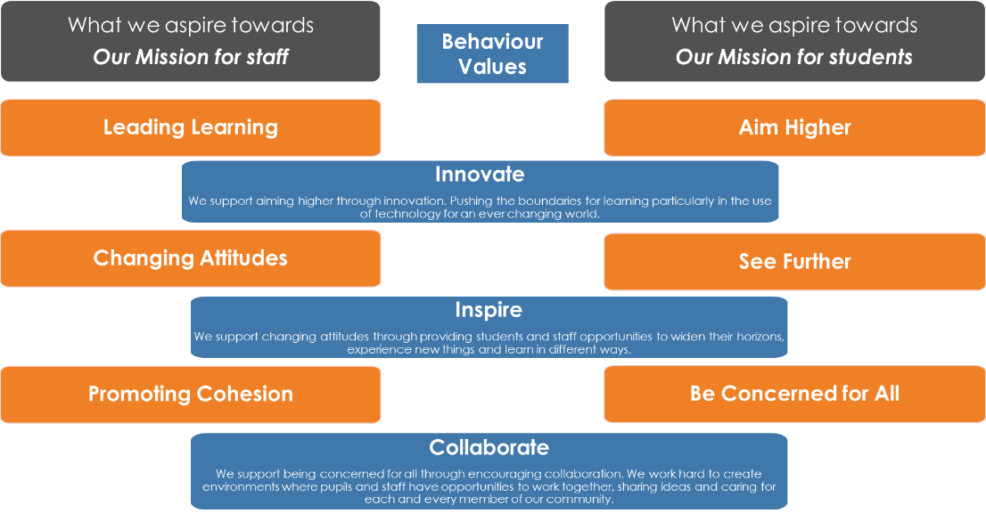

For the Students
Aim Higher – The Trust believes that success is possible for every child, that high expectations are in place for every student and that every student will make significant progress during their time at the school and that the Trust supports a strong, rigorous academic curriculum. Allied to this the Trust seeks a range of high quality technological and design experiences for students, ensuring they are skilled learners equipped with 21st century skills.

Changing Attitudes – The Trust believes every learner should aspire to a successful, fulfilling future and that they should have a strong careers awareness programme, filled with experiences which open their eyes to opportunity. The Trust seeks to promote the values of healthy lifestyles, good life choices and confident community participation. Students should be independent learners, curious about the world and seek to continually improve themselves.

Be Concerned for Everyone – The Trust believes that students should not just have an academic development, but a development which also looks at their personal characteristics, that they should have a strong sense of social responsibility, pride in their school and an outlook respectful of others regardless of race, faith, gender or background. The Trust will have an ethos of support which goes beyond the classroom, mitigating the effect of the high levels of deprivation within the community.

For the Staff and Leaders
Promoting Cohesion – The Trust believes in promoting a shared vision and sense of belonging by all of the communities that it serves reflecting the diversity and multi-dimensions of all cultures, religions, beliefs, ethnicities and social backgrounds. It believes in the equality of opportunity and good relations between different groups of people creating a sense of belonging by all communities and life opportunities available to all. By developing a strong sense of rights, responsibilities and trust within the school, wider local and global community, the Trust will help contribute towards building a more understanding, tolerant and fair society.

Leading Learning – The Trust believes in developing an ethos of learning for all, creating a culture of innovation, challenge and drive to create the very best learning experiences that drive forward school improvement and raise standards. It will encourage reflection across its staff and students that allow for pedagogical improvement. It will provide opportunities for classroom-based research which informs innovative programmes and a culture of developing the next generation of outstanding teachers of the future.

See Further – The Trust recognises the importance of developing learners for life. It will incorporate an innovative approach to careers awareness from the earliest of ages and develop in all, not only a love for learning, but a digitally supported toolkit that will support them through their learning lives. The Trust aims to support not only the academic skills needed to succeed but also to start to develop life-skills that prepare them for life outside of learning and a desire to expand horizons and raise aspirations.

Academy Principles

For Students
We believe that a student from West Bromwich can absolutely be the equal of any other student, nationally or internationally, if they are given the opportunity and we believe it is our task to provide students with those opportunities both through the curriculum and through the extracurricular activities we will provide.

We believe students should create work of real quality and be able to take some of the work they have done each year and want to keep it for the rest of their lives. We believe that low value tasks lead to low value outcomes.
Finally, and most importantly, we believe that students are the centre of our Academy. Through the opportunities, care, quality and relationships that we will give them we will create students who are:
- Happy, who feel their school and peers support them and want to come to school.
- Healthy, both mentally and physically.
- Successful, ambitious for themselves and others.
- Students who have strong aspirations and feel that they are capable of achieving them.
- Students with a sense of decency, respectful of others both within and beyond the Academy.
- Students with a sense of pride in their Academy, who want to be involved in all aspects of Academy life.
- Self motivated, inquisitive students, capable of independent study.
- Students who have a joy of learning and a wish to learn.
- Students who believe they can improve their skills and abilities through practice and hard work.
- Students who have strong and resilient coping mechanisms to deal with change.
- Students who are willing to take risks.
- Students who know how to stay safe outside of the Academy.
We want our student body to feel part of establishing the Academy and so we will be giving students opportunities to create ideas to become invested in the Academy and develop a sense of pride.

2. Legislation and guidance
This document meets the requirements of schedule 10 of the Equality Act 2010 and the Department for Education (DfE) guidance for schools on the Equality Act 2010.
The Equality Act 2010 defines an individual as disabled if he or she has a physical or mental impairment that has a ‘substantial’ and ‘long-term’ adverse effect on his or her ability to undertake normal day to day activities.
Under the Special Educational Needs and Disability (SEND) Code of Practice, ‘long-term’ is defined as ‘a year or more’ and ‘substantial’ is defined as ‘more than minor or trivial’. The definition includes sensory impairments such as those affecting sight or hearing, and long-term health conditions such as asthma, diabetes, epilepsy and cancer.
Schools are required to make ‘reasonable adjustments’ for students with disabilities under the Equality Act 2010, to alleviate any substantial disadvantage that a disabled student faces in comparison with non-disabled students. This can include, for example, the provision of an auxiliary aid or adjustments to premises.
This policy complies with our funding agreement and articles of association.
We are also aware that there can be substantial socio-economic, welfare and cultural challenges for students in accessing the curriculum and opportunities at the Academy. This Plan discusses the mitigation for those issues in addition to those with a physical or special need.

3. Action plan
This action plan sets out the aims of our accessibility plan in accordance with the Equality Act 2010.

Aim | Current good practice  Include established practice and practice under development | Objectives  State short, medium and long-term objectives | Actions to be taken | Person responsible | Date to complete actions by | Success criteria
Increase access to the curriculum for students with a disability –  Differentiation. | We will support all staff to be confident in differentiating the curriculum.  Our school offers a differentiated and inclusive curriculum for all students. | Deliver training on differentiation to all classroom-based staff.  All new staff to receive support with differentiation.  Review and evaluate the quality of differentiation within the classroom.  All themes and programmes of study to be accessible to all learners where appropriate. | INSET training on differentiation to be delivered during the Induction Programme.  Teaching and Learning Community INSET Programme to focus on differentiation.  Differentiation by support from Learning Support Staff.  Differentiation to be a focus in teacher lesson observations and appraisal.  Review each L4L theme prior to its delivery to ensure lessons are adequately differentiated to be accessible to all students with an appropriate level of challenge.  Teaching staff to plan and share differentiated resources via Teams. | DoLFL / SENCO / AP. | Ongoing. | Raised confidence of staff in using appropriate strategies for differentiation and increased student participation.  Students are able to access the curriculum due to appropriate differentiation, where appropriate.
Increase access to the curriculum for students with a disability –  Resources. | We use resources tailored to the needs of students who require support to access the curriculum.  Curriculum resources include examples of people with disabilities. | Each subject will analyse their curriculum and purchase appropriate resources and make reasonable adjustments for students to access the curriculum. | Resources to be purchased to ensure curriculum is accessible for all students in cohort.  Inclusion Department to acquire a bank of suitable resources to cover general learning and ICT which can be requisitioned by teachers and/or students as required.  PE, Science and Design to acquire equipment and resources and make appropriate adjustments for all learners to access the curriculum.  Risk assessments to be completed. | SENCO,  PE, Science, Design leads. | September 2020.  Ongoing. | Students are able to access the curriculum due to support from appropriate resources.
Increase access to the curriculum for students with a disability –  Extra-curricular and offsite. | We ensure that educational visits are accessible for students both experientially and financially, where reasonable adjustments are appropriate. | All students will access all extra-curricular activities and educational visits, where appropriate. | Consider the individual needs of students when selecting venues and activities.  Use Evolve software to assess risks for all visits and extra-curricular activities.  Ensure that relevant staff are trained to support students with additional needs in extra-curricular activities. | SENCO,  PE Team,  SLT. | Ongoing.  Ongoing. | All students will access all extra-curricular activities and educational visits, where reasonable adjustments can be made.  Students will be more engaged with learning and will contribute to the wider school community.
Increase access to the curriculum for students with a disability –  Progress. | Curriculum progress is tracked for all students, including those with a disability.  Targets are set effectively and are appropriate for students with additional needs.  The curriculum is reviewed so it meets the needs of all students. | All students will make at least expected progress. | Ensure resources purchased that include people with disabilities.  Online System Provision Mapping software used.  Curriculum is reviewed by Trust team and SIP Peter Johnson. | All teaching staff,  SENCO,  SLT. | Ongoing. | A range of resources are used to enhance the curriculum for all.  Staff and Senior Leaders can accurately track the progress of all students and support and extend where necessary.  Changes to curriculum can be made if necessary.
Improve and maintain access to the physical environment. | The environment is adapted to the needs of students as required.  This includes:  - Ramps  - Corridor width  - Disabled parking bays  - Disabled toilets and changing facilities  - Access to Reception and Conservatory  All staff are aware of access issues and needs of disabled students, staff and visitors.  Ensure that all disabled staff, students and visitors can be safely evacuated in an emergency.  Ensure all fire escape routes are suitable for all. | Phase 1 and 2 of the building has been designed and constructed to take account of these.  Signage is visible and in place. Evac chairs purchased, installed alongside training of key members of staff.  Clear Emergency and Fire Plan in place and regular practices carried out. | Access plans for individual disabled students, staff and visitors are circulated to relevant people.  Provide information to staff on disability and equality for all.  Monitor success and issues during standard fire practice and lockdown procedures.  Train all fire marshalls in the use of Evac Chairs. | SENCO.  Principal.  SLT/First Aider | Ongoing.  Ongoing.  Termly. | All staff, students and visitors can access all areas of the site.  Individual plan in place for all disabled students and all staff are aware of all students’ access needs.  All disabled students, staff and visitors and staff working with them are safe and confident in the event of a fire or emergency and are able to have safe evacuation.
Improve the delivery of information to students of parents/carers with a disability. | Our school uses a range of communication methods to ensure information is accessible. This includes:  - Internal signage  - Large print resources  - Use of plain English in all communication  - Website accessibility options | Ongoing. | All letters home are checked for understanding, audience, acronyms and plain English.  Clear and standard fonts are used in all signage and communication.  Family Questionnaires and Family Forum is used as a barometer for communication with families including accessibility. | Teaching Staff and Office Manager.  Principal.  Vice Principal. | Ongoing.  Ongoing.  Termly. | Communication is clear to all stakeholders.  School takes account of feedback so communication is continually improving.

4. Monitoring arrangements
This document will be reviewed every 3 years but may be reviewed and updated more frequently if necessary.
It will be approved by the WBCA Standards and Performance Committee.

5. Links with other policies
This accessibility plan is linked to the following policies and documents:
- Risk assessment policy
- Health and safety policy
- Equality information and objectives (public sector equality duty) statement for publication
- Special educational needs (SEN) information report
- Supporting students with medical conditions policy

Appendix 1: Accessibility audit

Feature | Description | Actions to be taken | Person responsible | Date to complete actions by
Number of storeys | 3 storey building. | N/A
Corridor access | All room are accessible from corridors. | N/A
Lifts | x1 operational lift covering 3 storeys. | N/A
Parking bays | 124 standard parking bays  6 disabled bays. | N/A
Entrances | x3 including main reception | N/A
Ramps | X 1 from car park, all other access is step free. | N/A
Toilets | 8x staff toilets  38x student toilets | N/A
Reception area | 22.78 m² | N/A
Internal signage | Yes – all emergency exits marked. | N/A
Emergency escape routes | Yes plus evacuation plan. | N/A

No actions are currently required. As Phase 1 of the building was completed in 2019 it was designed and built to be fully compliant with accessibility.
Phase 2 was completed in September 2021, also designed and built to be fully compliant with accessibility.

