Year 10 Foundation Maths Topics
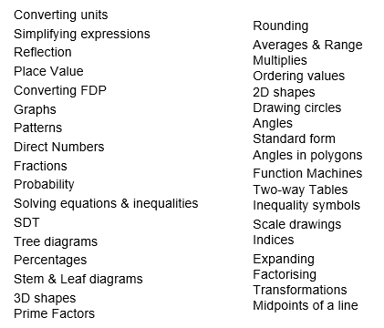

Year 10 Higher Maths Topics
