Year 9 Higher Maths Topics
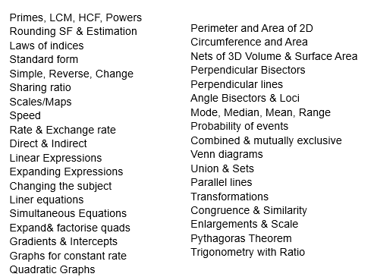
Year 9 Foundation Maths Topics
